A Few Tips for Sharing Wordless Picture Books

- There are no ‘right’ or ‘wrong’ ways to ‘read’ a wordless book. One of the wonderful benefits of using wordless books is how each child creates their own narrative from the same pictures.
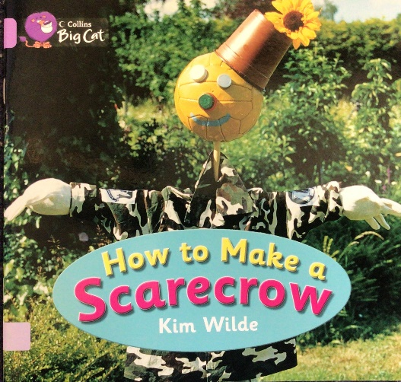

2. Firstly, spend time looking at the cover together and talking about the book title. Based on those two things; encourage your child to make predictions about the text.

- Now take a ‘picture walk’ through the pages of the book. Together, look carefully at the expressions on characters’ faces, the setting and the colours. Talk to each other about what you can see. These conversations will enrich your child’s early ‘reading’ skills and oracy.
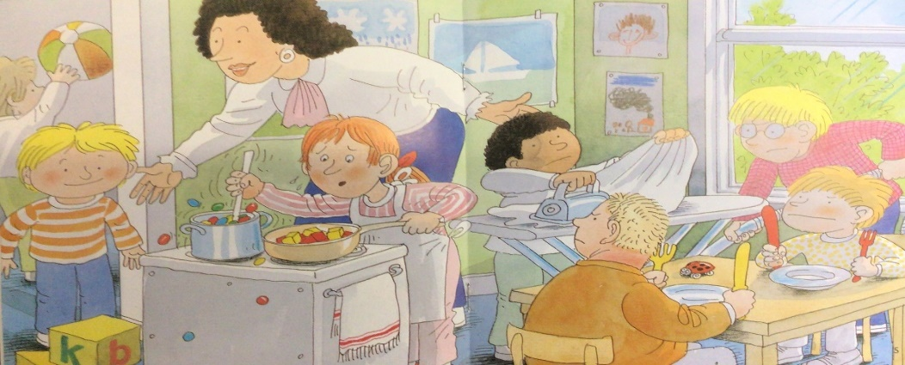

- Enjoy sharing the pictures together; and point out a few things to your child to encourage their verbal sequencing of the text. but don’t worry too much about telling a story yet. Just enjoy the pictures and get a sense of what the book is about.

- Go back through the book a second time and get ready for some great reading! Consider going first and acting as a model for your child. Use different voices for the characters, add sound effects and include interesting words, to expand your child’s vocabulary.

- Encourage your child to ‘read’ the book back to you. Focus on the words your child uses when they read the text. Help your child expand their sentences or thoughts by encouraging them to add information from the illustration’s details. One way to encourage more details is by asking ‘W’ questions: Who? Where? When? Why?

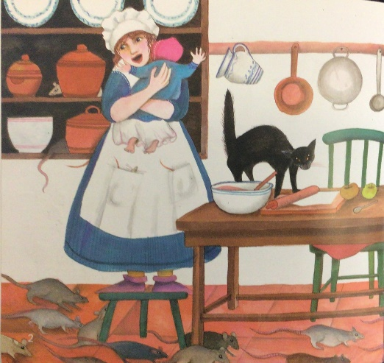
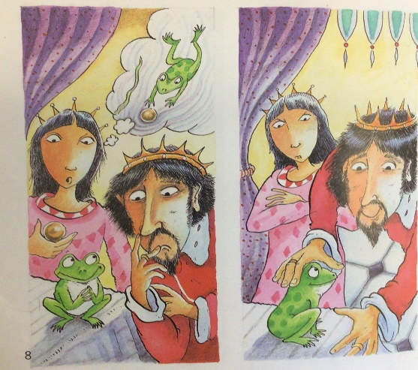

- Finally, sharing wordless books is a terrific way to build important literacy skills (ie: listening, vocabulary extension and comprehension). For a book with no words, you’ll be surprised at all the talking you will do, and all the fun you’ll have together!

